Cameron Hampton IAPS, PSA, SPS, APS
Innovative Pastel Painting Workshop
Wetumpka, Alabama @ The Kelly
Monday, April 24 - Tuesday, April 25, 2017 from 10am-4:30pm

$200 for two-day class. Deposit of $100 due by April 1, 2017
This Pastel Painting class @ The Kelly is for beginners to advanced artists. All levels are welcome.
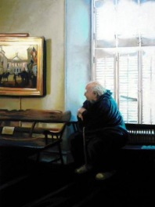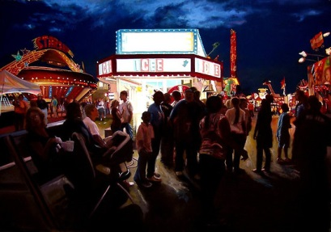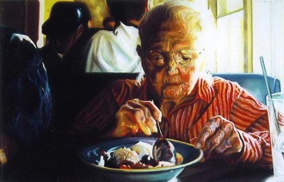
Join Cameron Hampton for this new innovative way to use pastels for exciting paintings! Students will learn the basics of pastel painting, the latest pastel painting materials such as surfaces and tools to use for more dynamic pastel paintings.
Learn about creating values, composition, textures, use complimentary underpainting, setting up a good still life, choosing a good photograph to work from, subject matter, tones, color and the realization of light to create vibrant pastel paintings. Also, materials and pastel brands, fixative and framing will be explained. Students will be working from photographs and still life.
Cameron will supply some optional art supplies as supplies last.
: *Materials needed are minimal. Students need to bring to class:
- Basic set of pastels
- Pad or sheets of pastel paper
- Photograph’s to work from *Teacher will supply photograph’s too
- Drawing board
- Tabletop easel (optional)
- Apron or artist smock (optional)
Cameron Hampton is a Masters Circle Member of the International Association of Pastel Societies, earning her Gold Medal in the spring of 2007. She is also a Signature Member of the Pastel Society of America, the Southeastern Pastel Society and the Alabama Pastel Society. She is a painter, photographer, sculptor and illustrator. Hampton attended both Pratt Institute in Brooklyn, New York and The Atlanta College of Art (now The Savannah College of Art and Design) in Atlanta, Georgia. Also, she has studied independently in Austria, Belgium, The Netherlands, Slovakia, and Hungary where she lived. Hampton has works in corporate and private collections throughout the world such as Ovation TV, Sprint, Canada, Hungary, The Netherlands, England and Belgium. Her work is currently represented by Carré d’artistes in Utrecht, Netherlands. http://artistcameronhampton.wix.com/cameronhampton

Registration Form
Innovative Pastel Painting Workshop with Cameron Hampton
Monday, April 24 - Tuesday, April 25, 2017 from 10am-4:30pm

$200 for two-day class. Deposit of $100 due by April 1, 2017

This Pastel Painting class @ The Kelly is for beginners to advanced artists. All levels are welcome.
Workshop Address: 408 South Main Street, Wetumpka, Alabama 36092
Date _________________________________________________
Name ________________________________________________
Address ______________________________________________
City, State, Zip Code ____________________________________
Phone Number _________________________________________
Email Address _________________________________________
- $100 Non-refundable workshop deposit included: Please make checks payable to The Kelly. Please note pastel workshop on the memo line of your check. The remaining $100 will be payable when you arrive on April 24, 2017 @ 10am.
- I prefer to pay for the entire workshop. I have included a $200 check payable to The Kelly. Please note pastel workshop on the memo line of your check.

Please mail this form and your check to the address below:
The Kelly
Pastel Painting Workshop
P.O. Box 641
Wetumpka, Alabama 36092

Please Register Early…Space is Limited to 35 Participants!

